Final Report

1. Abstract

In this project, we consider the knowledge of the freshmen and the advanced course of electrical engineering, using tracking car as our basis. However, we have several other features, such as PID control system, App programming and modular programming, etc., hoping to encourage our students interest, self learning the impact of PID parameters. By doing so, students would be able to learn how to optimize a system and compromise among several attributes, to fulfill their goals. In the end, this course would path the way to electrical engineering and explore deeper theory.

在這個教案中，我們考慮到大一新生的能力以及電機系高年級的課程，使用循跡自走車當作我們的基礎。然而，在其中有 PID 系統、App 程式設計以及模組化程式設計等，希望激發學生的興趣，進而自主學習各種參數對系統的影響。如此，學生將學會如何優化系統，在各個不同的特性中取得平衡，從而達到自己的目標。在教案結束後，這門課程將為電機系新生前往電機系各個領域鋪路，促使新生探索更深入的理論。

1. Content
   1. Overview

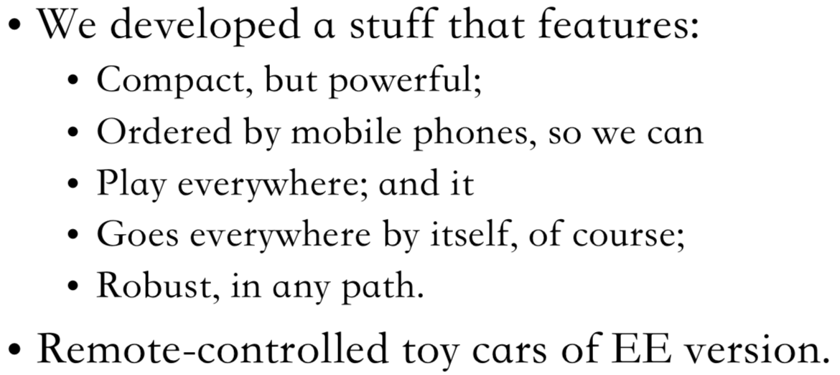

What will the first-year learn is:

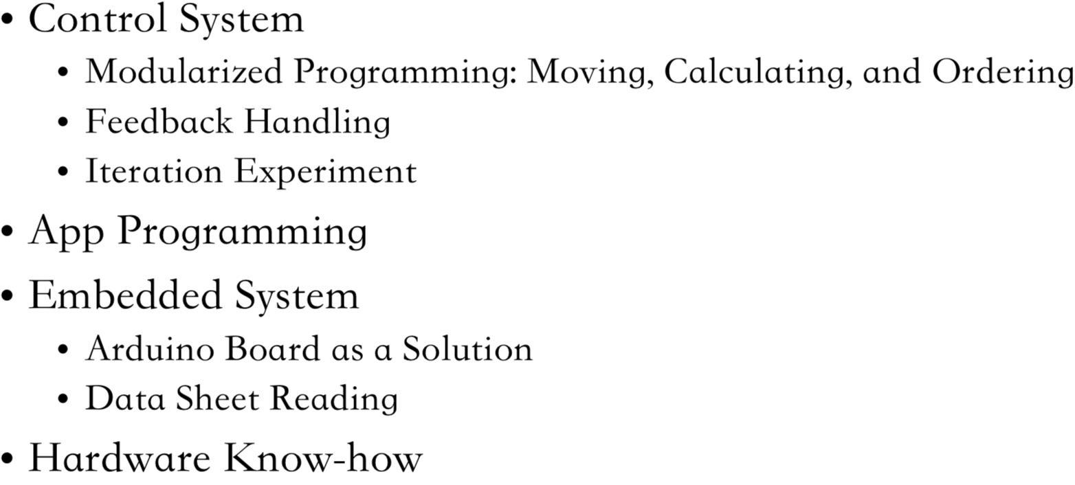

* 1. Hardware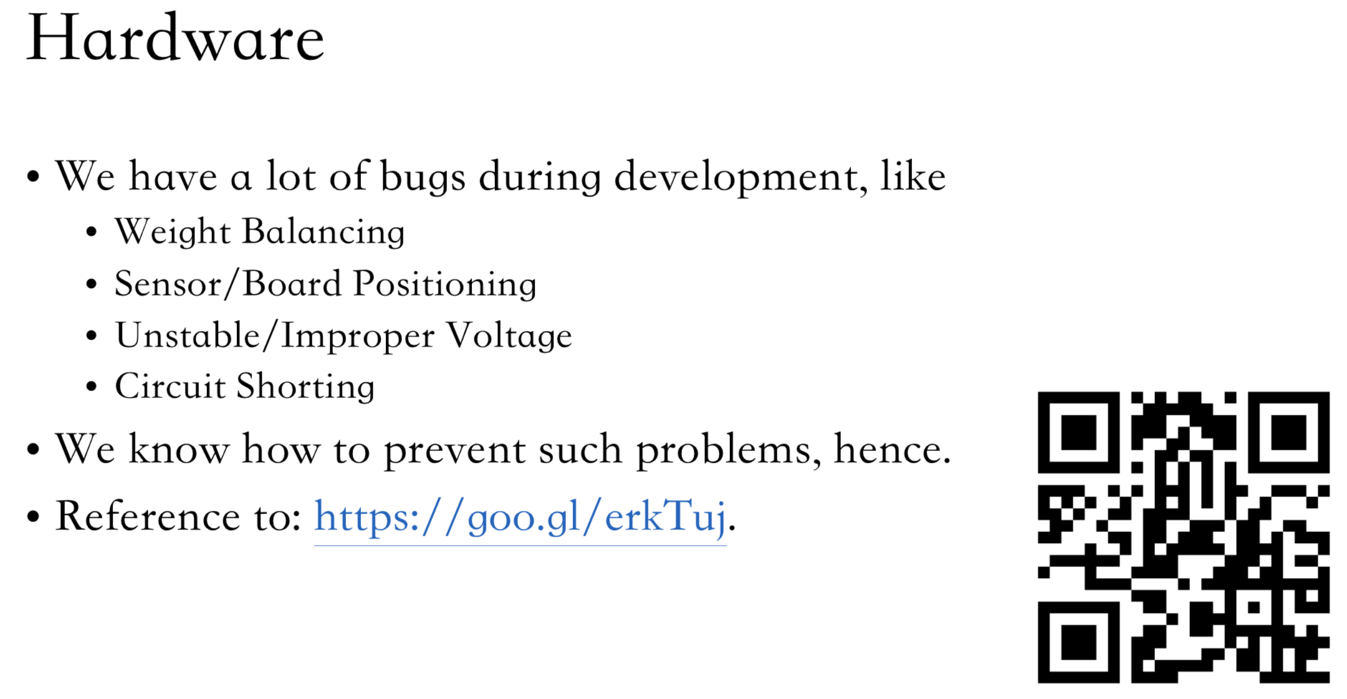
  2. Tracking System

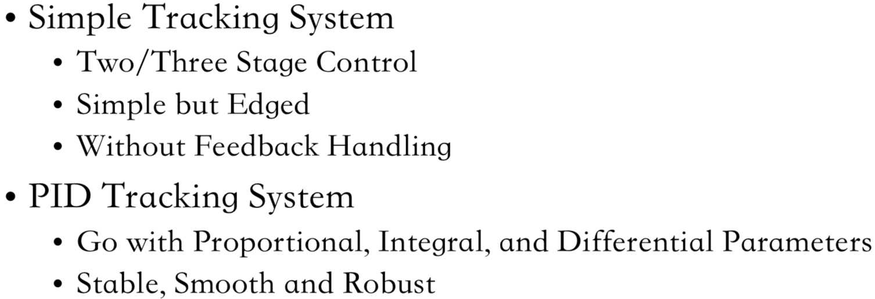

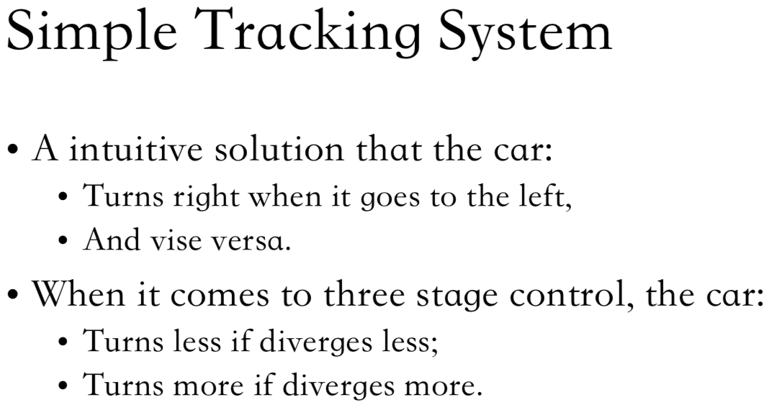

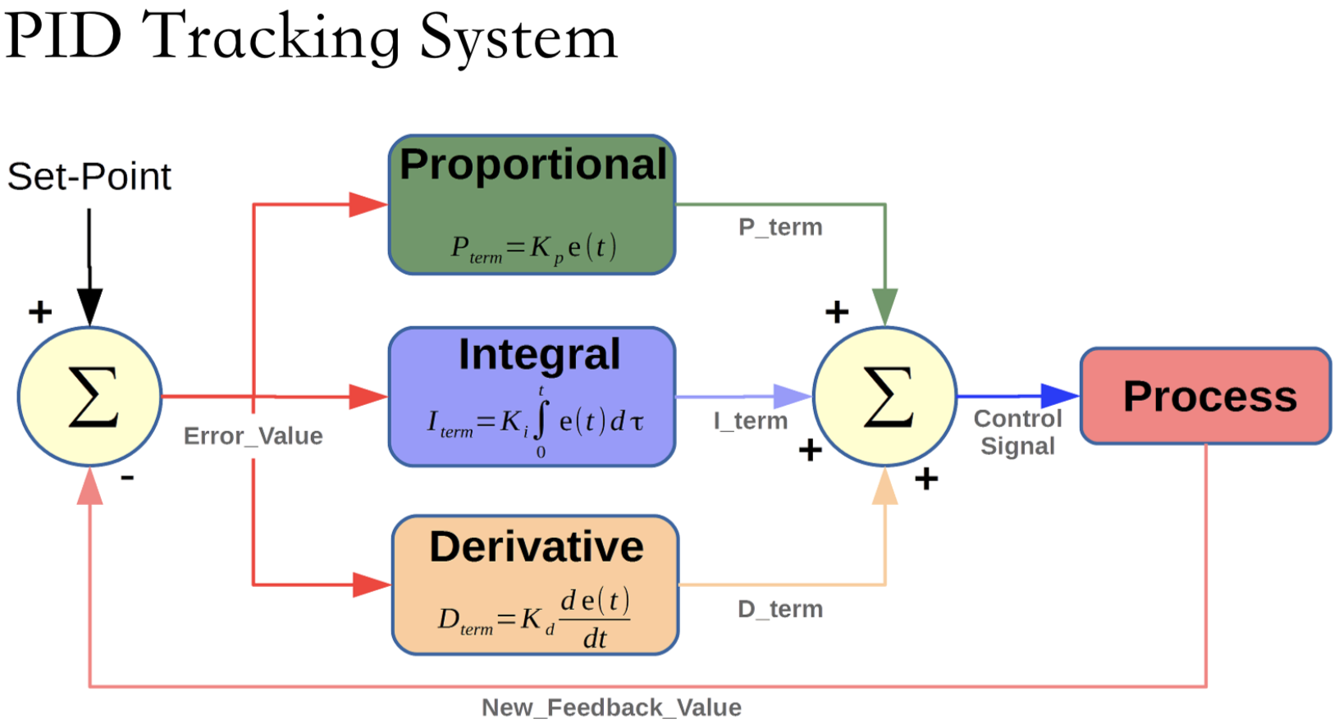

System Block Diagram

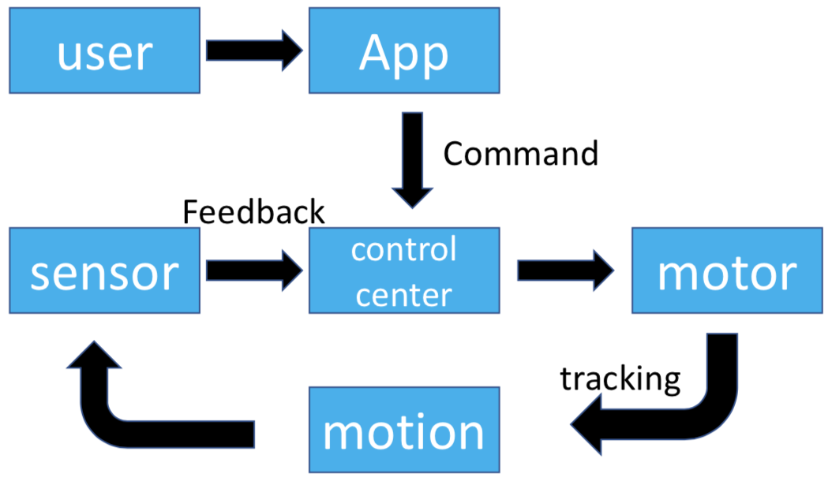

* 1. Control System

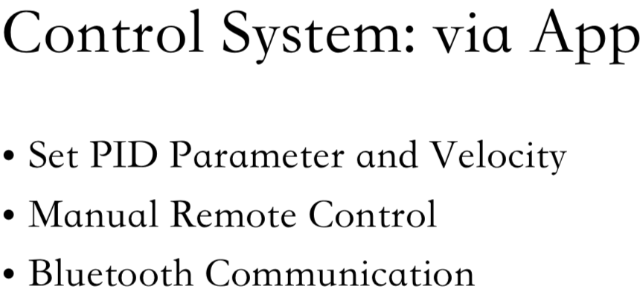

* 1. Eight-week Units

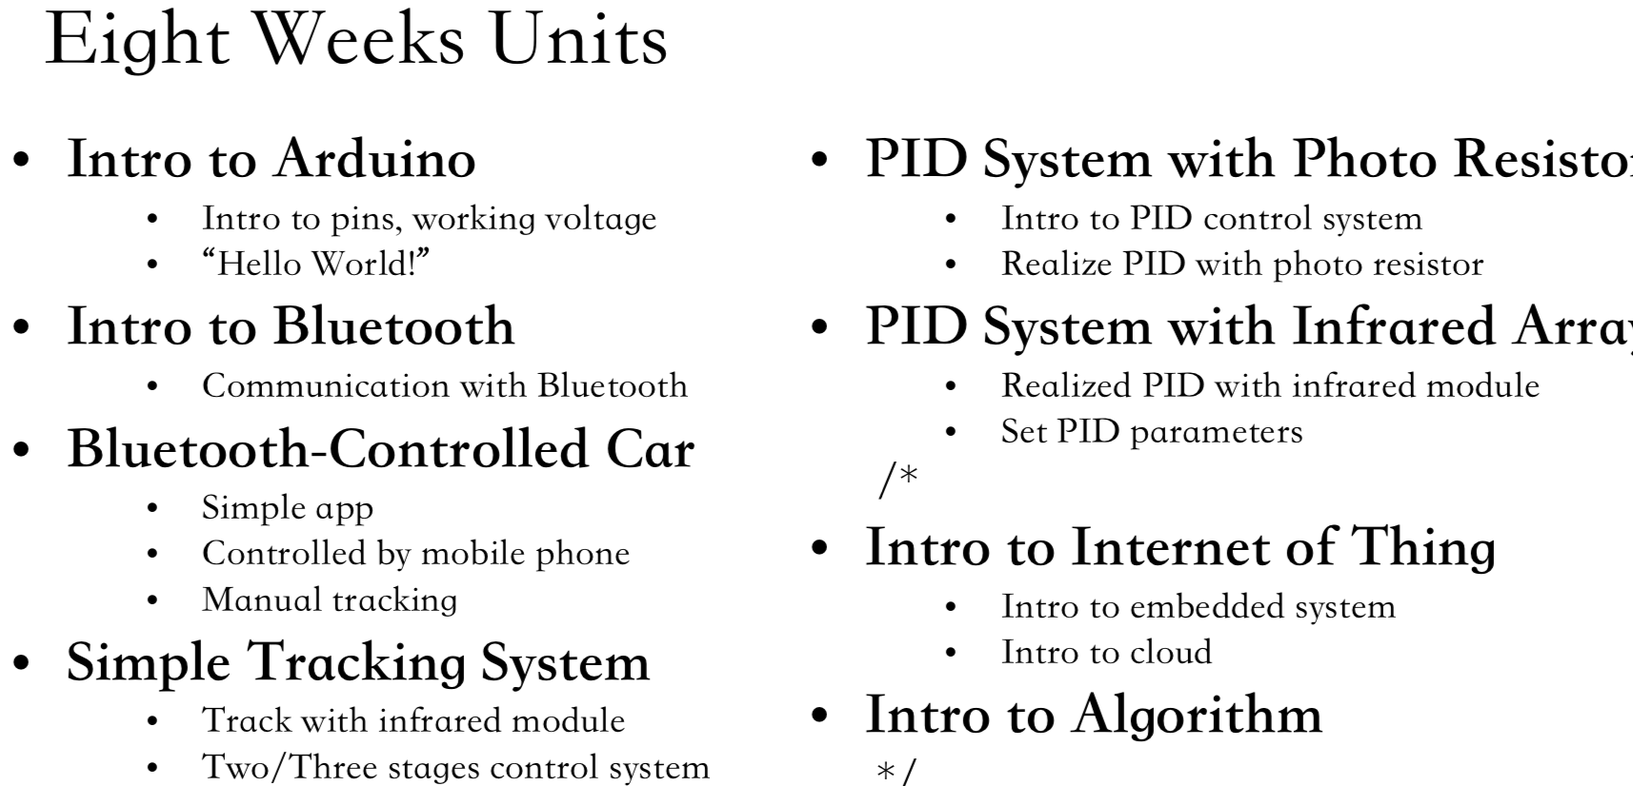

* 1. Conclusion

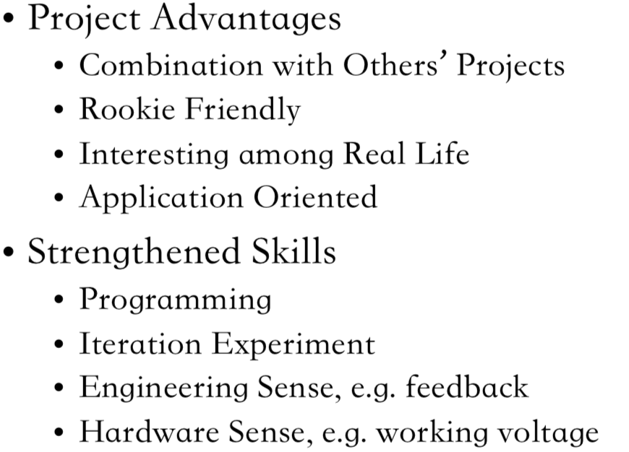

1. Reference
   1. PID Basic Introduction:

<http://robotrabbit.blogspot.tw/2012/07/pid.html>

* 1. Bluetooth App Document:

<http://www.appinventor.tw/ai2_connectivity_bluetoothclient>

* 1. Arduino Bluetooth tutorial:

<https://goo.gl/PulGt8>

* 1. PID Tracking:

<https://goo.gl/HaRghX>

* 1. Tracking Car Video:

<https://www.youtube.com/watch?v=zBu6nEFLTJE>